Tutor+

User Manual

Version 1.0 - Tutor Squad – 12/2/2018

**Chapter 1: Getting Started**

1. **Overview**

This manual is divided into two chapters:

**Chapter 1: Getting Started**

This chapter contains information about installing and uninstalling Tutor+. It also contains information on how you can get help while using Tutor+.

**Chapter 2: Tutor+ User Tutorial**

This chapter contains lessons for using Tutor+. Each lesson is self-contained and can be completed in short blocks of time.

1. **System Requirements**

To ensure the best performance using Tutor+, please note the following requirements for hardware and software:

**Hardware**: iPhone devices with 4.7-inch screen display (iPhone 6, 6s, 7, 8)

**Software**: iOS 12.0 or later

1. **Install Tutor+**

Before installing Tutor+, make sure your device meets the minimum requirements necessary for using Tutor+ (See “System Requirements” above)

**To install Tutor+:**

1. Uninstall any existing versions of Tutor+ you have installed. (See “Uninstall Tutor+” on the next page).
2. Open Xcode on a device with MacOS and run Tutor+ project.
3. Connect your iPhone to the running device and select your iPhone in the drop down list by clicking the button in the top left part of Xcode.



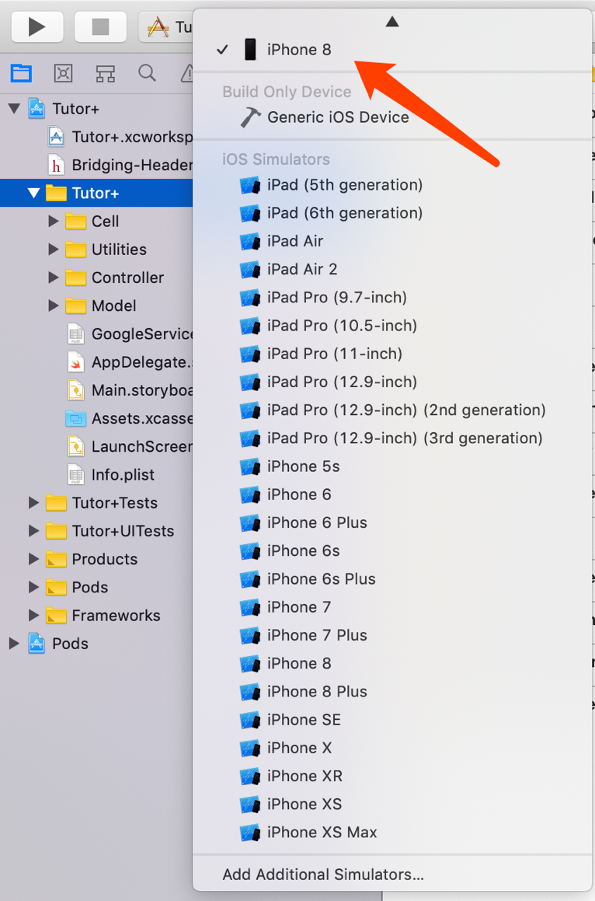

1. Press the Play button to install and wait for a while when it is finishing installation.



1. **Uninstall Tutor+**

**To uninstall Tutor+ on your device:**

1. Hold the icon of Tutor+ and then click the cross button.

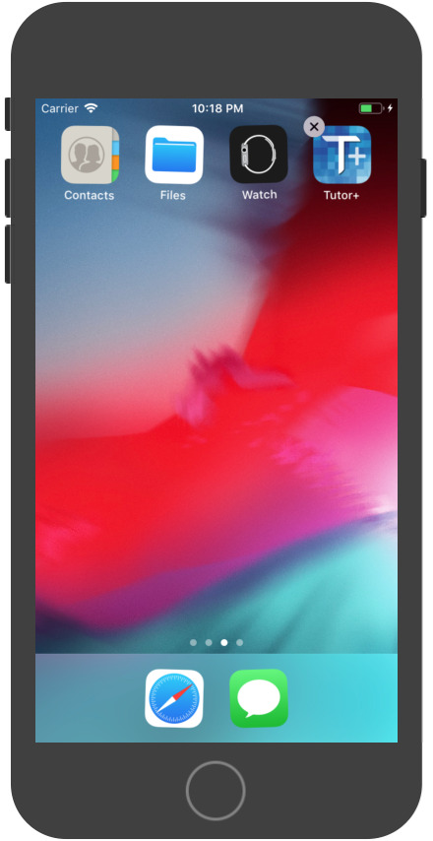

1. Follow the on-screen prompts to remove Tutor+.

**Chapter 2: Tutor+ User Tutorial**

1. **Sign up / Login / Log out**

**To sign up:**

1. Click the blue sign up button at the bottom of login page, and then input the requested information to finish sign up.

**To login:**

1. Login in with the email address and the password you have.
2. To login with Google account, click the Google sign in button and follow the on-screen prompts.

**To log out:**

1. Go to you profile page and log out (See “Personal Profile” below)

**2. Personal Profile**

**To see your profile:**

1. Click the Featured button.

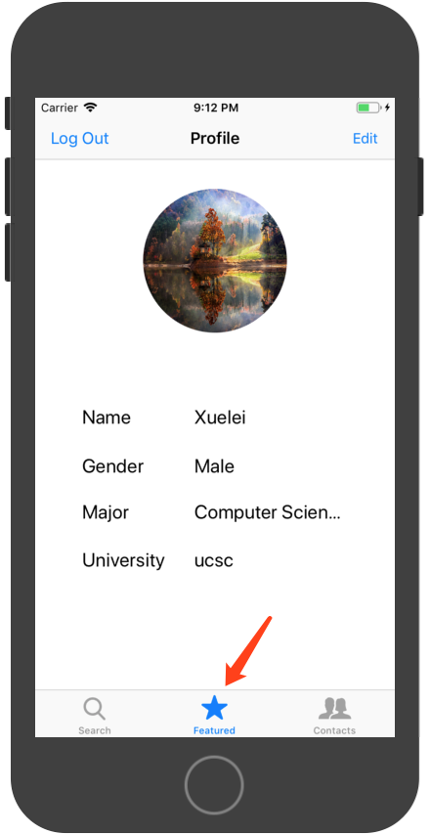

**To edit profile:**

1. Click the Edit button at the top right.

2. Edit your icon, name, gender and etc.

3. Click the Save button when finishing editing.

**3. Want to be a tutor?**

**To edit tutor profile**:

1. Click the switch button when editing profile.

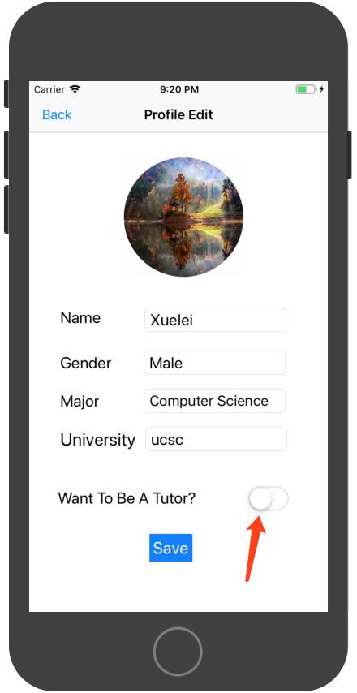

2. Set courses and schedules.

3. Click the time blocks that you are available, then it will be highlighted.

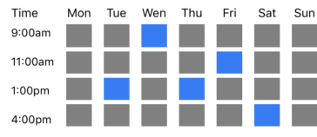

4. Click the Save button when finishing.

**To accept or decline students’ request:**

1. Go to Contacts page (See “” below).

2. Click the Accept or Decline button.

**4. Search**

1. Search tutors via schools and course numbers.

2. There are four recommendations of the most popular tutors.

**To request a tutor:**

1. Click the bar of a specific tutor and go to his/her profile page.

2. Click the Request button do send a request.

**5. Online Conversations**

**To have online conversation with your tutors and/or students:**

1. Click the Contacts button.

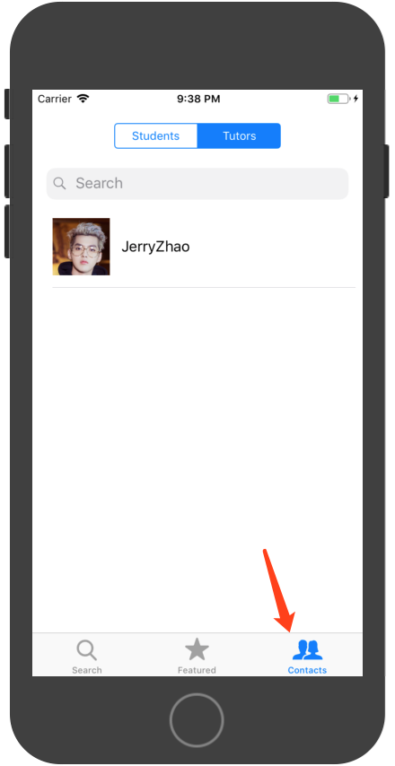

2. Click the tutor/student bar to start a conversation.

3. Click the switch button at the top to chat with tutors or students.